Topics

- Spring and spring boot
- Difference
- Spring-boot basics ,components

Micro-services..
- Basics
- Architecture
- Service Discovery
  - Client Side
Client-Side discovery pattern: Client talks directly with the service registry to receive the IP addresses of a certain service and uses its own load balancing algorithm to choose one of them. Although this approach is simple and straigtforward, it couples service discovery logic with clients.
  - Server Side
Server-Side discovery pattern: Client makes requests to a load balancer or an API gateway, which routes the requests to corresponding services. In this case API gateway is aware of the service registry and load balancing, which leaves clients abstracted from the service discovery logic. Maintaining a single point of failure API gateway is the main drawback of this approach.

Server-side service discovery allows clients applications to find services through a router or a load balancer
Router
/
Gateway
Client-App

Client-side service discovery allows clients applications to find services by looking through or querying a service registry, in which service instances and endpoints are all within the service registry.

To better understand client and server side discovery..
https://lalverma.medium.com/spring-boot-microservices-implementing-service-discovery-cfc98e49b74f

Opensource tools for service discovery
- Consul
- Etcd
- Apache ZooKeeper

- MAVEN

Yaml files-spring boot profiles
JAVA-8 predicate functional interface

- Micro services
- API Gateways
- Service Discovery
- Security
- Tools
- Docker
- Kubernetes
- SOA vs Microservices
- Microservice Design Patterns
- OKTA / OpenID
- Sso
- Saml
- Opened connect
- Oauth

SAML -
- CA Certificate
- PRIVATE Key
- A certificate signing request (CSR) is one of the first steps towards getting your own SSL Certificate.

Micro-service Architecture-----------

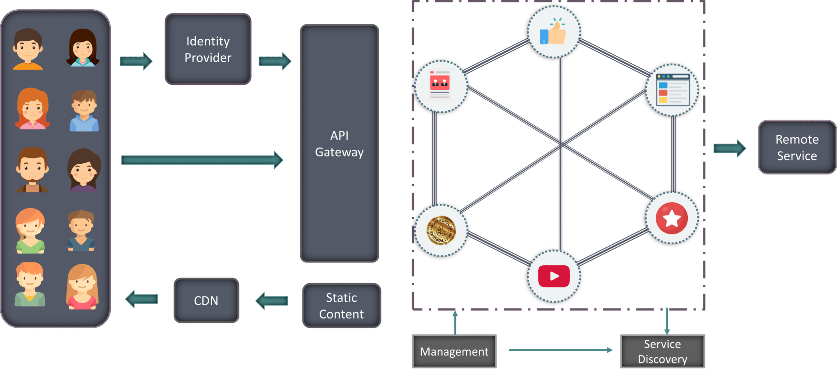
An edge service is a component which is exposed to the public internet. It acts as a gateway to all other services, which we will refer to as platform services. For example, consider an Nginx reverse proxy in front of some web resource servers. ... An example edge service: Nginx as a reverse proxy for two resource servers.

API Gateway (FAÇADE PATTERN) https://smartbear.com/learn/api-design/api-gateways-in-microservices/
Spring Cloud Gateway provides a library to build an API Gateway.
- Azure Application Gateway
https://docs.microsoft.com/en-us/dotnet/architecture/microservices/architect-microservice-container-applications/direct-client-to-microservice-communication-versus-the-api-gateway-pattern
- Netflix API Gateway.
- Netflix Zuul Gateway
- Amazon API Gateway

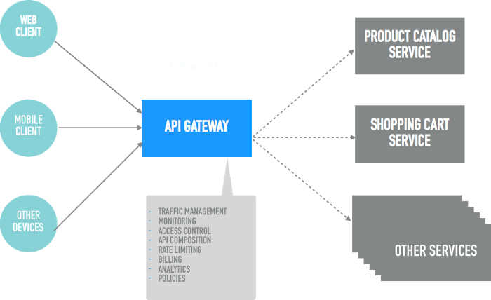

Service Discovery..
https://www.nginx.com/blog/service-discovery-in-a-microservices-architecture/
- NETFLIX Eureka
- Zookeeper
- consul

Problems :
TCP port exhaustion..
CMIS
MS database.. whoISActive, Whois2
OCR/ICR
SSO/SAML ,IDP
Micro-service

Practical way…….

1. Springboot SAML/OKTA example..
This example basically covers the SAML(A&A) concept using well known IDP okta/ping federate or Salesforce.

Exercise :

OKTA-SpringBoot………
Fortunately, there’s no need. Spring Security and Spring Boot have made implementing a web application using OAuth 2.0 nice and simple. And Okta, a software-as-service identity access provider, have built on top of Spring Boot to make the process even easier.

- Multi-factor Authentication

Microservice Uundestanding..

Architecture
Client Side Service Discovery
(Eureka server)
https://www.youtube.com/watch?v=GboiMJm6WlA&t=6s
Server side service discovery..
(AWS,NGINX)

